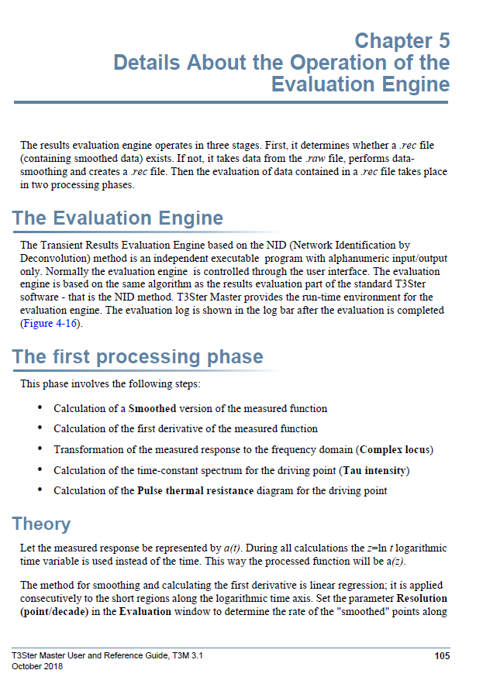

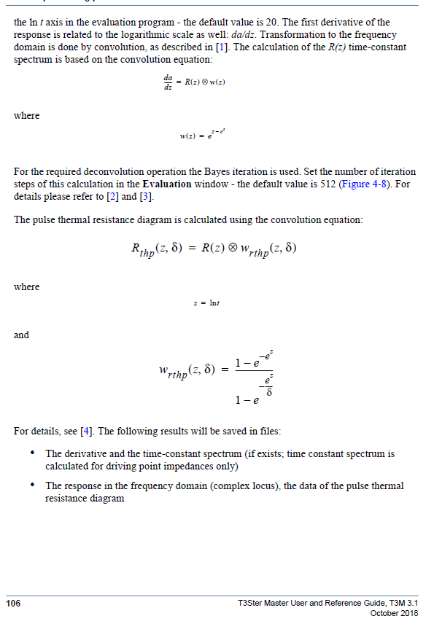

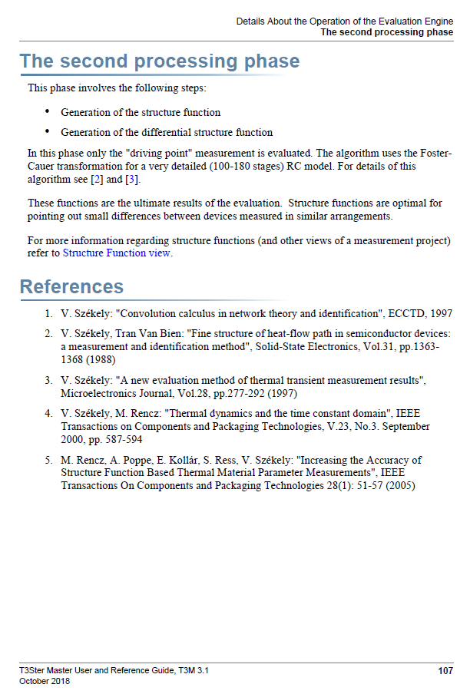

1. V. Székely: "Convolution calculus in network theory and identification", ECCTD, 1997

Can’t find paper.

1. V. Székely, Tran Van Bien: "Fine structure of heat-flow path in semiconductor devices:

a measurement and identification method", Solid-State Electronics, Vol.31, pp.1363-

1368 (1988)

This is a highly relevant source.

1. V. Székely: "A new evaluation method of thermal transient measurement results",

Microelectronics Journal, Vol.28, pp.277-292 (1997)

1. V. Székely, M. Rencz: "Thermal dynamics and the time constant domain", IEEE

Transactions on Components and Packaging Technologies, V.23, No.3. September

2000, pp. 587-594

1. M. Rencz, A. Poppe, E. Kollár, S. Ress, V. Székely: "Increasing the Accuracy of

Structure Function Based Thermal Material Parameter Measurements", IEEE

Transactions On Components and Packaging Technologies 28(1): 51-57 (2005)